

**Appendix 1**

**Arkansas Aviation’s Operations**

**2020**



**Arkansas Aviation Operation Plan**

**Primary & Secondary Airports**

**Airport Information**

# Batesville Regional: BVX

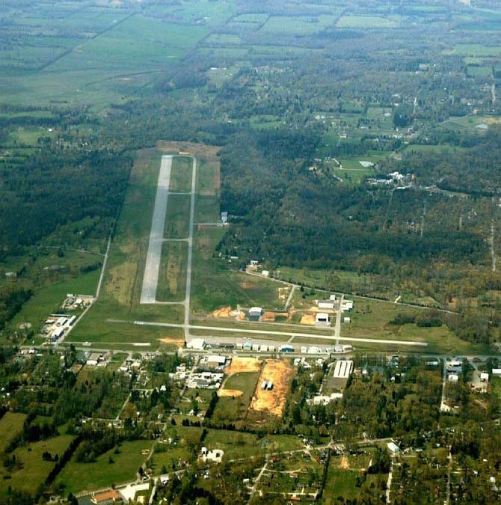

|  |  |  |  |  |  |  |  |  |  |
| --- | --- | --- | --- | --- | --- | --- | --- | --- | --- |
| **Latitude** | | | **Longitude** | | | | **Elevation** | | |
| **35-43-34.4000N** | | | **091-38-50.8000W** | | | | **465’** | | |
| **Runway** | **Surface** | **Width** | | **Length** | **Unicom** | | | **Fuel** | **Attended** |
| **08-26**  **18-36** | **Asphalt Asphalt** | **150’**  **60’** | | **6002’**  **2804’** | **122.8** | | | **100LL**  **Jet A** | **0730-1730** |
| **Manager** | | | **Phone** | | | **City** | | | **Miles** |
| **Darren Wilkes** | | | **(870) 251-1244** | | | **Batesville** | | | **3 South** |

**Airport Services: Major Repairs, Fuel after Hrs (Fee Charged) 870-251-2326**

# Batesville Regional: BVX

Baxter County: BPK

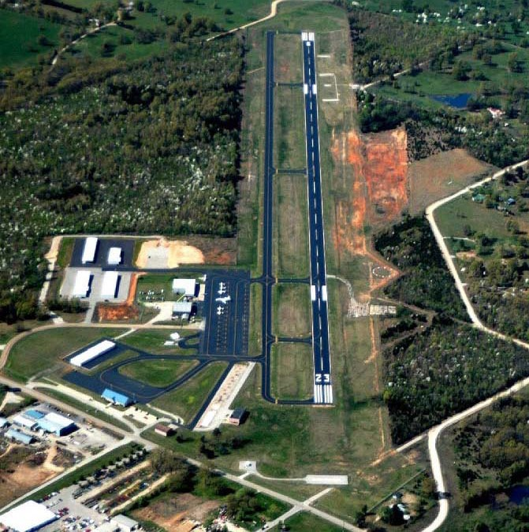

|  |  |  |  |  |  |  |  |  |  |
| --- | --- | --- | --- | --- | --- | --- | --- | --- | --- |
| **Latitude** | | | **Longitude** | | | **Elevation** | | | |
| **36-22-08.1910N** | | | **092-28-13.9010W** | | | **928’** | | | |
| **Runway** | **Surface** | **Width** | | **Length** | **Unicom** | | **Fuel** | **Attended** | |
| **05-23** | **Asphalt** | **75’** | | **5000’** | **123.0** | | **100LL-Jet A** | **0700-1700** | |
| **Manager** | | | **Phone** | | | **City** | | | **Miles** |
| **Kathy Frederick** | | | **(870) 481-5418** | | | **Mountain Home** | | | **4 NW** |

**Airport Services: Major Repairs**

Baxter County: BPK

Fort Smith Regional (FSM) 139

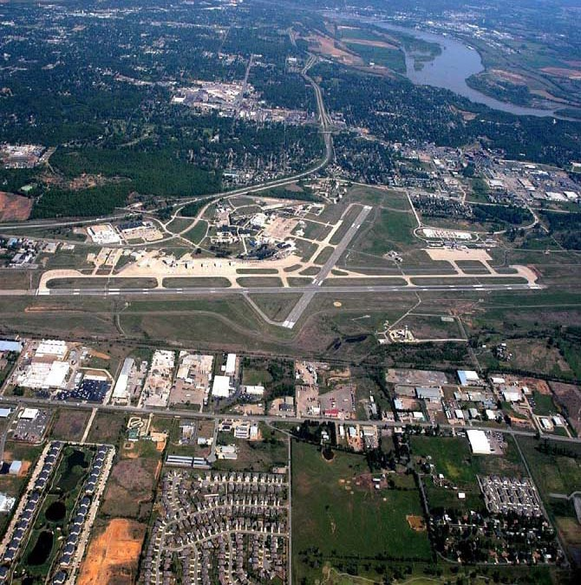

|  |  |  |  |  |  |  |  |  |  |
| --- | --- | --- | --- | --- | --- | --- | --- | --- | --- |
| **Latitude** | | | | **Longitude** | | | **Elevation** | | |
| **35-20-11.7000N** | | | | **094-22-02.8000W** | | | **469’** | | |
| **Runway** | **Surface** | | **Length** | | **Width** | **Unicom** | | **Fuel** | **Attended** |
| **01-19**  **07-25** | **Asphalt Asphalt** | | **5001’**  **8017’** | | **150’**  **150’** | **122.95** | | **100LL**  **Jet A** | **0800-1700** |
| **Manager** | | | | **Phone** | | | **City** | | **Miles** |
| **Michael Griffin** | | | | **(479) 452-7000** | | | **Fort Smith** | | **3 SE** |
| **AWIN** | | **HF** | | **Airport Services: Major Repair** | | | | | |

Fort Smith Regional (FSM) 139

Grider Field (PBF)

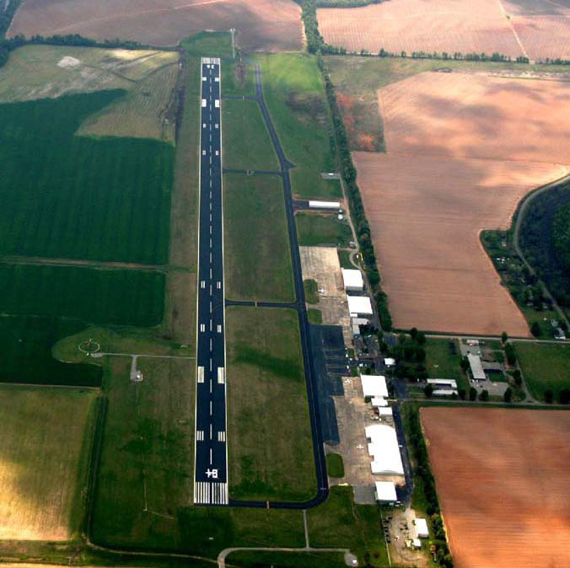

|  |  |  |  |  |  |  |  |  |  |
| --- | --- | --- | --- | --- | --- | --- | --- | --- | --- |
| **Latitude** | | | | **Longitude** | | | **Elevation** | | |
| **34-10-28.2470N** | | | | **091-56-08.1752W** | | | **205.7’** | | |
| **Runway** | **Surface** | | **Length** | | **Width** | **Unicom** | | **Fuel** | **Attended** |
| **18-36** | **Asphalt** | | **5998’** | | **150’** | **123.0** | | **100LL-Jet A** | **0800-1800** |
| **Manager** | | | | **Phone** | | | **City** | | **Miles** |
| **Doug Hale** | | | | **870-534-4131** | | | **Pine Bluff** | | **4 SE** |
| **AWIN** | | **HF** | | **Airport Services: Self Serve Fuel 24hrs w/Credit Card** | | | | | |

Grider Field (PBF)

Little Rock National (LIT) 139

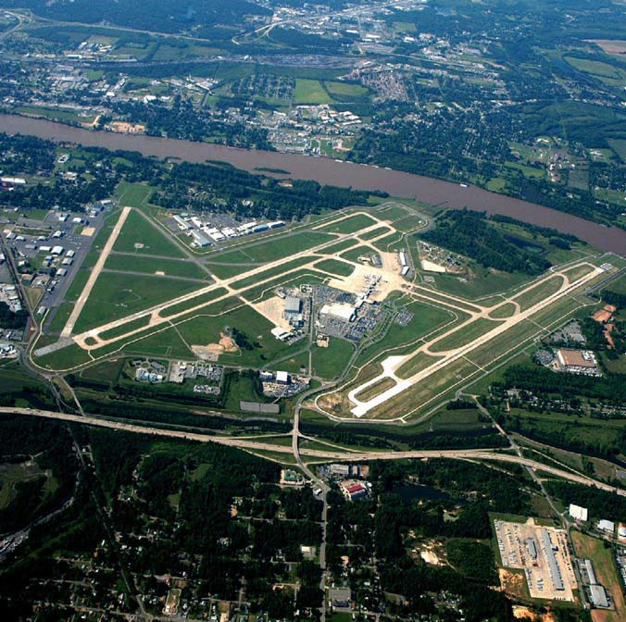

|  |  |  |  |  |  |  |  |  |  |
| --- | --- | --- | --- | --- | --- | --- | --- | --- | --- |
| **Latitude** | | | | **Longitude** | | | **Elevation** | | |
| **34-43-46.0000N** | | | | **092-13-29.2000W** | | | **266’** | | |
| **Runway** | **Surface** | | **Length** | | **Width** | **Ground** | | **Fuel** | **Attended** |
| **04L-22R**  **04R-22L**  **18-36** | **Concrete Concrete Concrete** | | **8273’**  **8251’**  **6224’** | | **150’**  **150’**  **150’** | **121.9** | | **100LL**  **Jet A** | **24/7** |
| **Manager** | | | | **Phone** | | | **City** | | **Miles** |
| **Bryan Malinowski** | | | | **501-372-3439** | | | **Little Rock** | | **2 East** |
| **AWIN** | | **HF** | | **Airport Services: Major Repair** | | | | | |

**\*Helipad 50’x50’**

Little Rock National (LIT) 139

Memorial Field (HOT) 139

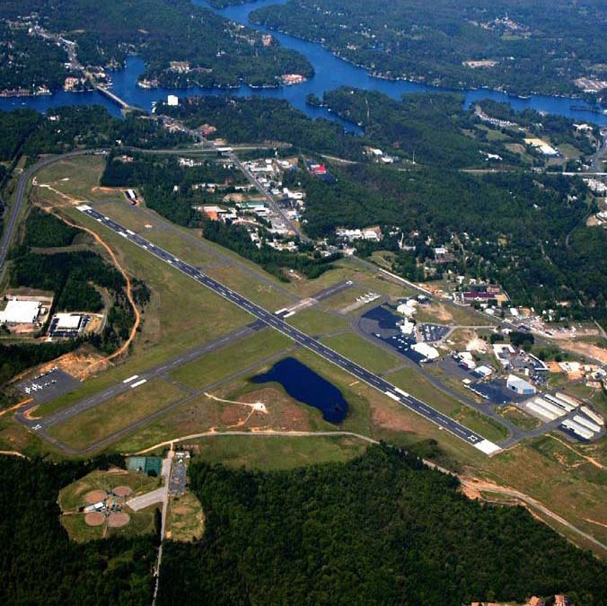

|  |  |  |  |  |  |  |  |  |  |
| --- | --- | --- | --- | --- | --- | --- | --- | --- | --- |
| **Latitude** | | | | **Longitude** | | | **Elevation** | | |
| **34-28-40.9000N** | | | | **093-05-46.4000W** | | | **540’** | | |
| **Runway** | **Surface** | | **Length** | | **Width** | **Unicom** | | **Fuel** | **Attended** |
| **05-23**  **13-31** | **Asphalt Asphalt** | | **6595’**  **4098’** | | **150’**  **100’** | **123.0** | | **100LL**  **Jet A** | **0500-2200** |
| **Manager** | | | | **Phone** | | | **City** | | **Miles** |
| **Glen Barentine** | | | | **501-321-6750** | | | **Hot Springs** | | **3 SW** |
| **AWIN** | | **HF** | | **Airport Services: Major Repair** | | | | | |

Memorial Field (HOT) 139

Stuttgart Municipal (SGT)

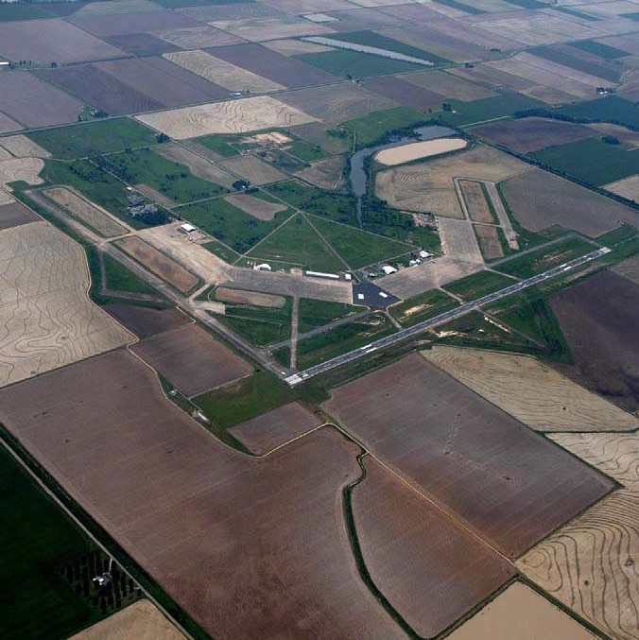

|  |  |  |  |  |  |  |  |  |  |
| --- | --- | --- | --- | --- | --- | --- | --- | --- | --- |
| **Latitude** | | | | **Longitude** | | | **Elevation** | | |
| **34-35-58.1227N** | | | | **091-34-30.0010W** | | | **224’** | | |
| **Runway** | **Surface** | | **Length** | | **Width** | **Unicom** | **Fuel** | **Attended** | |
| **09-27**  **18-36** | **Concrete Asphalt** | | **5002’**  **6015’** | | **150’**  **100’** | **122.8** | **100LL**  **Jet A** | **Nov-Jan 0800-1900**  **Feb-Oct 0800-1630** | |
| **Manager** | | | | **Phone** | | | **City** | | **Miles** |
| **Carl Humphrey** | | | | **(870) 673-2960** | | | **Stuttgart** | | **7 North** |
| **AWIN** | | **Airport Services: Minor Repair** | | | | | | | |

**\*Airport located in Prairie County**

**\* Helipad 60’x60’**

Stuttgart Municipal (SGT)

Walnut Ridge Regional (ARG)

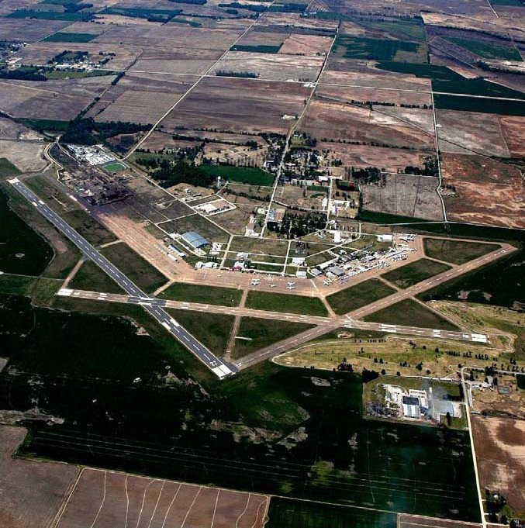

|  |  |  |  |  |  |  |  |  |  |
| --- | --- | --- | --- | --- | --- | --- | --- | --- | --- |
| **Latitude** | | | | **Longitude** | | | **Elevation** | | |
| **36-07-28.8000N** | | | | **090-55-30.4000W** | | | **279’** | | |
| **Runway** | **Surface** | | **Length** | | **Width** | **Unicom** | | **Fuel** | **Attended** |
| **04-22**  **13-31**  **18-36** | **Asphalt Concrete Concrete** | | **6001’**  **5003’**  **5001’** | | **150’**  **150’**  **150’** | **122.8** | | **100LL**  **Jet A** | **24/7** |
| **Manager** | | | | **Phone** | | | **City** | | **Miles** |
| **Stacy Hoggard** | | | | **(870) 886-5432** | | | **Walnut Ridge** | | **4 NE** |
| **Armature Radio** | | **Airport Services: Major Repair** | | | | | | | |

Walnut Ridge Regional (ARG)

Arkansas International: BYH

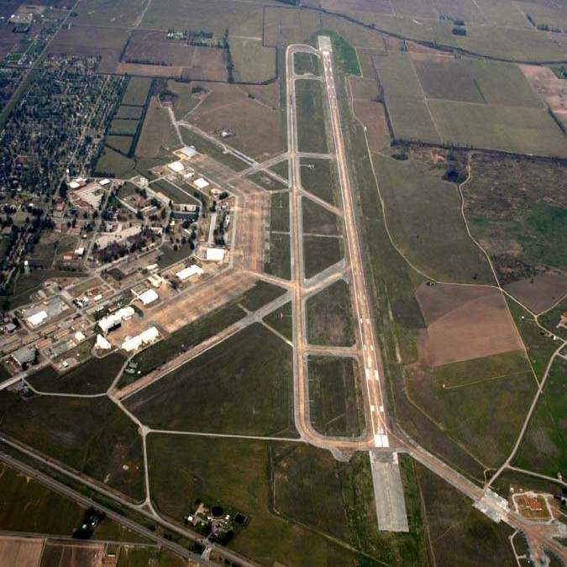

|  |  |  |  |  |  |  |  |  |
| --- | --- | --- | --- | --- | --- | --- | --- | --- |
| **Latitude** | | | **Longitude** | | | **Elevation** | | |
| **35-57-51.6000N** | | | **089-56-38.2000W** | | | **254’** | | |
| **Runway** | **Surface** | **Length** | | **Width** | **Unicom** | | **Fuel** | **Attended** |
| **18-36** | **Concrete** | **11602’** | | **150’** | **122.7** | | **100LL-Jet A** | **0800-1700** |
| **Manager** | | | **Phone** | | | **City** | | **Miles** |
| **Todd Riley** | | | **(870) 532-5628** | | | **Blytheville** | | **3 NW** |

**Airport Services: Major Repairs**

Arkansas International: BYH

Boone County Regional (HRO)

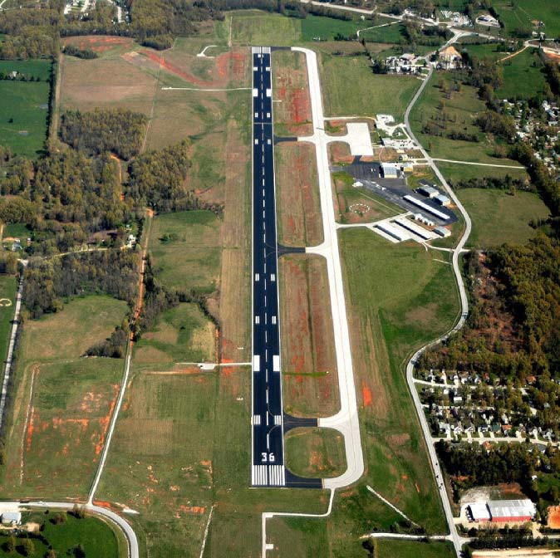

|  |  |  |  |  |  |  |  |  |
| --- | --- | --- | --- | --- | --- | --- | --- | --- |
| **Latitude** | | | **Longitude** | | | **Elevation** | | |
| **36-15-41.4740N** | | | **093-09-17.0240W** | | | **1364.5’** | | |
| **Runway** | **Surface** | **Length** | | **Width** | **Unicom** | | **Fuel** | **Attended** |
| **18-36** | **Asphalt** | **6161’** | | **150’** | **123.0** | | **100LL-Jet A** | **0700-1900** |
| **Manager** | | | **Phone** | | | **City** | | **Miles** |
| **Judy McCutcheon** | | | **(870) 741-6954** | | | **Harrison** | | **3 NW** |

**Airport Services: Minor Repairs, Self-Serve Fuel 24hrs**

Boone County Regional (HRO)

Drake Field (FYV) 139

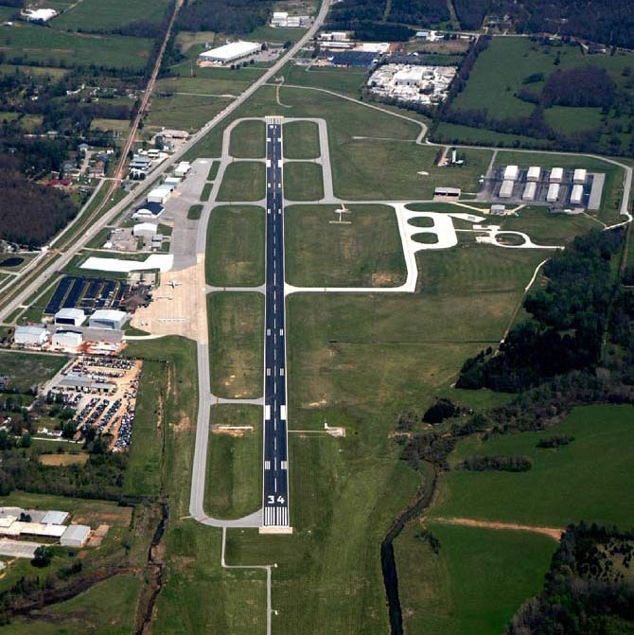

|  |  |  |  |  |  |  |  |  |
| --- | --- | --- | --- | --- | --- | --- | --- | --- |
| **Latitude** | | | **Longitude** | | | **Elevation** | | |
| **36-00-18.3000N** | | | **094-10-12.2000W** | | | **1252’** | | |
| **Runway** | **Surface** | **Length** | | **Width** | **Unicom** | | **Fuel** | **Attended** |
| **16-34** | **Asphalt** | **6005’** | | **100’** | **122.95** | | **100LL-JetA** | **0600-2200** |
| **Manager** | | | **Phone** | | | **City** | | **Miles** |
| **Summer Fallen fFFallenFallen** | | | **(479) 718-7642** | | | **Fayetteville** | | **3 South** |
| **AWIN** | **Airport Services: Minor Repairs** | | | | | | | |

Drake Field (FYV) 139

Jonesboro Municipal (JBR)

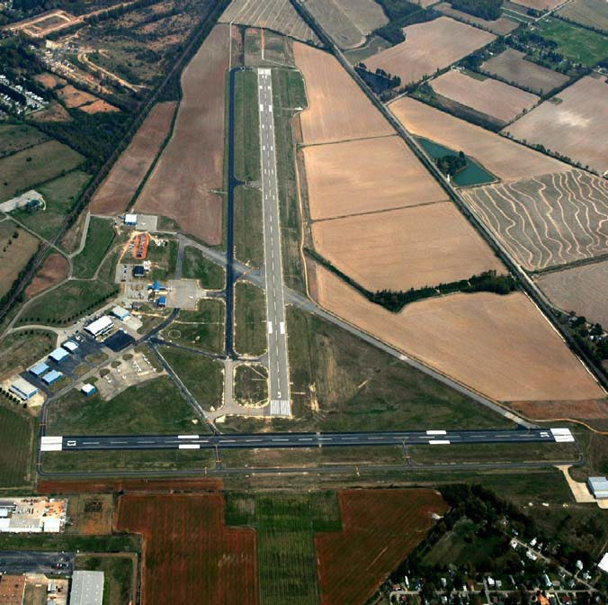

|  |  |  |  |  |  |  |  |  |
| --- | --- | --- | --- | --- | --- | --- | --- | --- |
| **Latitude** | | | **Longitude** | | | **Elevation** | | |
| **35-49-54.2000N** | | | **090-38-47.1000W** | | | **262’** | | |
| **Runway** | **Surface** | **Length** | | **Width** | **Unicom** | | **Fuel** | **Attended** |
| **05-23**  **13-31** | **Asphalt Asphalt** | **6200’**  **4099’** | | **150’**  **150’** | **123.0** | | **100LL**  **Jet A** | **0600-2100** |
| **Manager** | | | **Phone** | | | **City** | | **Miles** |
| **George Jackson** | | | **(870) 761-4149** | | | **Jonesboro** | | **3 East** |

**Airport Services: Major Repairs**

Jonesboro Municipal (JBR)

Newport Municipal (M19)

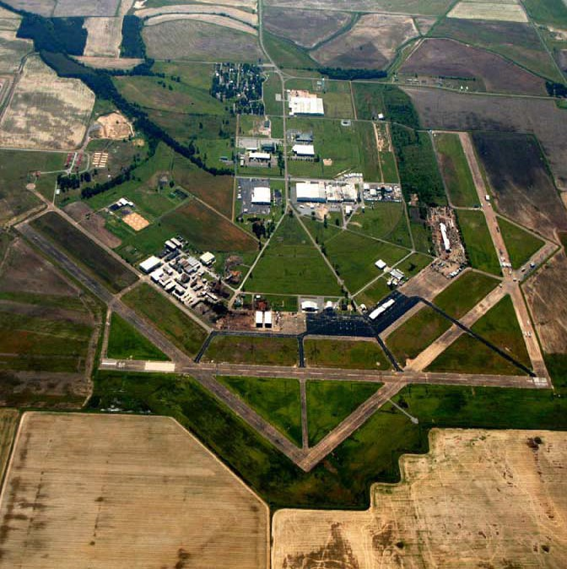

|  |  |  |  |  |  |  |  |  |
| --- | --- | --- | --- | --- | --- | --- | --- | --- |
| **Latitude** | | | **Longitude** | | | **Elevation** | | |
| **35-38-15.8000N** | | | **091-10-35.0000W** | | | **239’** | | |
| **Runway** | **Surface** | **Length** | | **Width** | **Unicom** | | **Fuel** | **Attended** |
| **04-22**  **18-36** | **Concrete Concrete** | **5002’**  **5002’** | | **150’**  **150’** | **122.8** | | **100LL**  **Jet A** | **M-S 0800-1700**  **Sun 1300-1700** |
| **Manager** | | | **Phone** | | | **City** | | **Miles** |
| **Jim Martin** | | | **(870) 523-3613** | | | **Newport** | | **5 NE** |

**Airport Services: Major Repairs, Self-Serve Fuel Available After Hrs ONLY w/Credit Card**

Newport Municipal (M19)

**Northwest Arkansas Regional (XNA) 139**

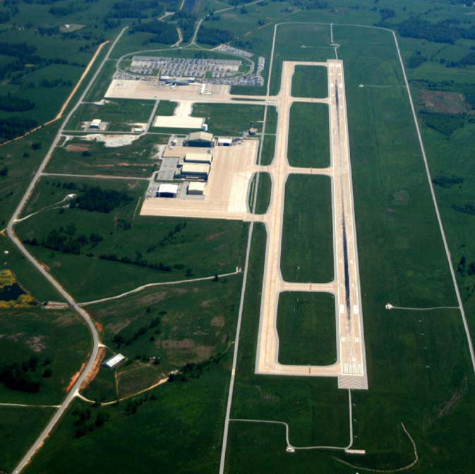

|  |  |  |  |  |  |  |  |  |  |
| --- | --- | --- | --- | --- | --- | --- | --- | --- | --- |
| **Latitude** | | | | **Longitude** | | | **Elevation** | | |
| **36-16-53.6858N** | | | | **094-18-27.9592W** | | | **1288’** | | |
| **Runway** | **Surface** | | **Length** | | **Width** | **Ground** | | **Fuel** | **Attended** |
| **16-34** | **Concrete** | | **8801’** | | **150’** | **121.9** | | **100LL-Jet A** | **24/7** |
| **17-35** | **Concrete** | | **8800’** | | **150’** |  | |  |  |
| **Manager** | | | | **Phone** | | | **City** | | **Miles** |
| **Kelly Johnson** | | | | **(479) 205-1000** | | | **Bentonville** | | **15 NW** |
| **AWIN** | | **HF** | | **Airport Services: For Fuel Service Use Freq 130.05** | | | | | |

**Northwest Arkansas Regional (XNA) 139**

Russellville Regional (RUE)

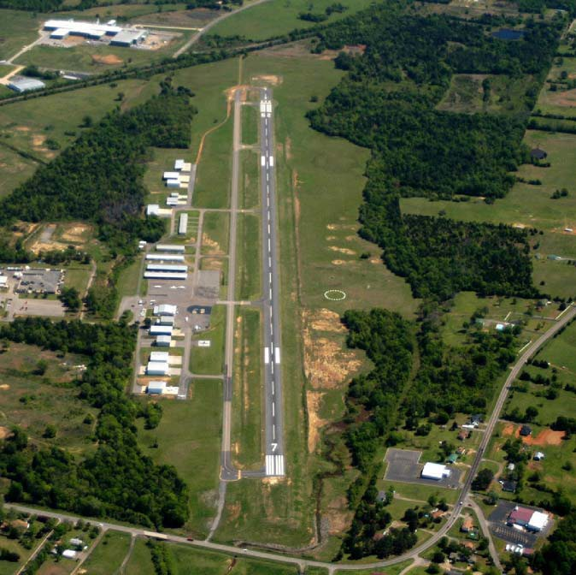

|  |  |  |  |  |  |  |  |  |
| --- | --- | --- | --- | --- | --- | --- | --- | --- |
| **Latitude** | | | **Longitude** | | | **Elevation** | | |
| **35-15-32.9280N** | | | **093-05-35.7580W** | | | **409’** | | |
| **Runway** | **Surface** | **Length** | | **Width** | **Unicom** | | **Fuel** | **Attended** |
| **07-25** | **Asphalt** | **5505’** | | **75’** | **122.7** | | **100LL-Jet A** | **0800-1700** |
| **Manager** | | | **Phone** | | | **City** | | **Miles** |
| **Keith Frazier** | | | **(479) 967-1227** | | | **Russellville** | | **2 SE** |

**Airport Services: Major Repairs**

Russellville Regional (RUE)

# Searcy Municipal (SRC)

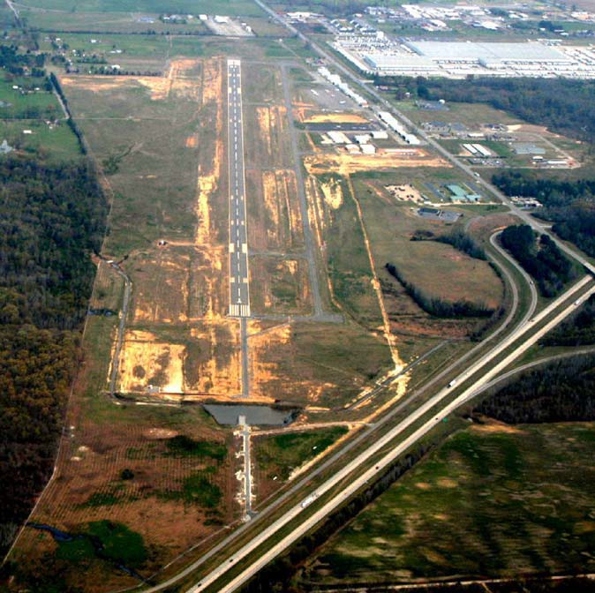

**Airport Services: Major Repairs, Self-Serve 100LL with Credit Card**

|  |  |  |  |  |  |  |  |  |  |
| --- | --- | --- | --- | --- | --- | --- | --- | --- | --- |
| **Latitude** | | | | **Longitude** | | | **Elevation** | | |
| **35-12-38.1950N** | | | | **091-44-15.1420W** | | | **264’** | | |
| **Runway** | **Surface** | | **Width** | | **Length** | **Unicom** | | **Fuel** | **Attended** |
| **01-19** | **Asphalt** | | **100’** | | **6008’** | **112.7** | | **100LL-Jet A** | **0700-1800** |
| **Manager** | | | | **Phone** | | | **City** | | **Miles** |
| **Roger Pearson** | | | | **(501)279-1080** | | | **Searcy** | | **3 South** |
| **AWIN** | | **HF** | |  | | | | | |

**Jet A Service After Hrs Call 501-279-1080**

# Searcy Municipal (SRC)