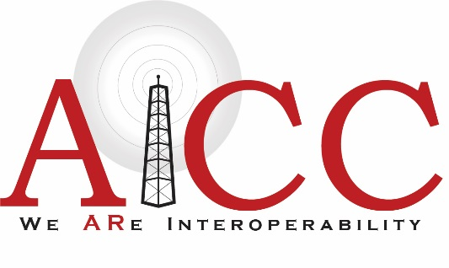
Glenn “Sonny” Cox Award for Excellence
In Public Safety Communications
Nomination Form
Deadline for Submission: July 16, 2021

Your (Nominator’s) Information:

Name: Click here to enter your name.
Agency Name: Click here to enter the agency you work for.
Mailing Address: Click here to enter your mailing address.
City: Click here to enter your city. State: AR Zip Code: Click here to enter text.
Email: Click here to enter text.
Phone: Click here to enter text.

Do you perform any services in a public safety discipline, either paid or voluntary?
Choose an item.

What is your job title? Click here to enter your job title.

Information About Nominee:

Name: Click here to enter name of Nominee.
Agency Name: Click here to enter Nominee’s agency.
Mailing Address: Click here to enter Nominee’s mailing address.
City: Click here to enter City. State: AR Zip Code: Click here to enter Zip Code.
Email: Click here to enter Nominee’s email.
Phone: Click here to enter Nominee’s phone.

Nominee’s Award Qualifications:

Does the Nominee reside in the state of Arkansas? Choose an item.

Did the Nominee participated in active work, either paid or unpaid, for a public safety agency in Arkansas in 2020? Choose an item.

Nominee’s Job Title in 2020: Click here to enter Nominee’s job title.

Please provide a brief description of the Nominee’s public safety duties, particularly regarding communications:
Click here to enter text.

Describe the Nominee’s level of job knowledge and skill in his/her area of emergency communications:
Click here to enter text.

How does the Nominee share his/her job knowledge and expertise with others?
Click here to enter text.

To your knowledge, has the Nominee sought self-improvement through continuing education, training or certification? Please describe what you know:
Click here to enter text.

Please describe how the Nominee demonstrate exceptional dedication to service and job performance in public safety communications.
Click here to enter text.

Please describe how the Nominee contributes to a collaborative, team-oriented work environment:
Click here to enter text.

How does the Nominee demonstrate the highest level of personal and professional conduct in his/her duties? Please provide an example:
Click here to enter text.

In addition to the above, please explain why you believe this Nominee is an excellent candidate for the award:
Click here to enter text.

Deadline for Submission: July 16, 2021
Email form to: Rachel.Wilson@adem.arkansas.gov
Call Rachel Wilson at (501) 683-0491 for questions.

Thank you very much for your submission. Careful consideration will be given to all submissions and we may contact you if clarification is needed on any point.
We hope that you will be present for the Award Presentation at the:

2021 Arkansas Emergency Management Conference
August 24-27, 2021
Embassy Suites Northwest Arkansas Hotel, Spa & Convention Center
Rogers, Arkansas

