2024 ACT 833 Funding Guidance
and Requirements
Application Due by June 30th, 2024

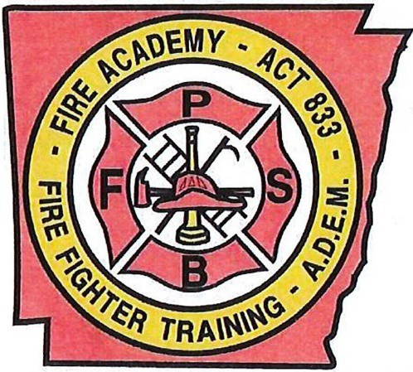
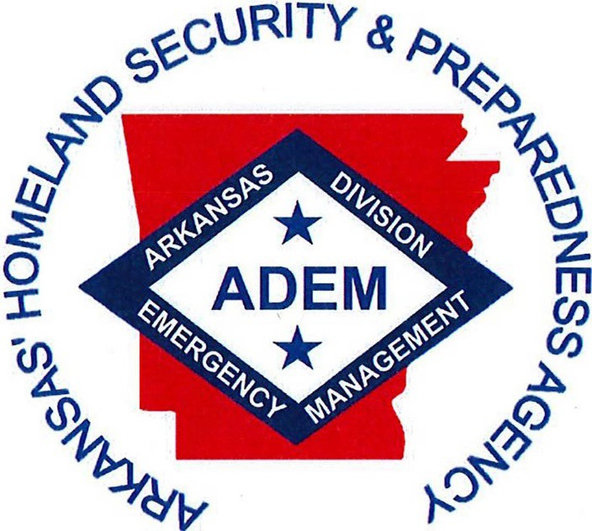
FIRE PROTECTION
SERVICES BOARD
Office of Fire Protection Services

C/O Arkansas Fire Protection Service Board & Office of Fire Protection Services
ARKANSAS DIVISION OF EMERGENCY MANAGEMENT
Building #9501 - Camp Joseph T. Robinson North Little Rock, Arkansas 72199-9600

Louis Eckelhoff - State Fire & Field Services Office
(501) 683-6781 Office - (501) 683-7890 Fax

Email: Louis.Eckelhoff@ADEM.Arkansas.Gov

WEB SITE: www.dps.arkansas.gov

MIKE HAGAR  SECRETARY | STATE OF ARKANSAS GOVERNOR SARAH SANDERS  DEPARTMENT OF PUBLIC SAFETY DIVISION OF EMERGENCY MANAGEMENT | A.J. GARY  DIRECTOR

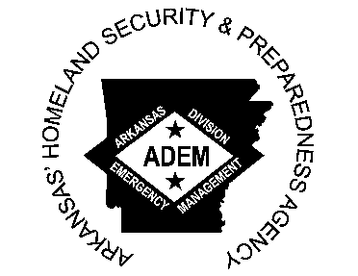
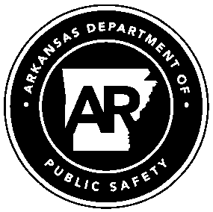
TO: Arkansas Fire Departments

FROM: Office of Fire Protection Services / Arkansas Division of Emergency Management Louis Eckelhoff, State Fire & EMS Coordinator

DATE: 2024 Funding Period (Opens Jan. 1, 2024 - Closes June 30, 2024)

SUBJECT: Application Guidance, Certification Forms, Invoices, Training Requirements, & Audits

Application Forms:
Act 833 application will be submitted online only through the Fire Service Portal on the ADEM web site (www.dps.arkansas.gov) under "Useful Links".
Applications will be completed online, and submitted by midnight on June 30th. Any application received after the deadline date will not be funded. All applications returned for corrections after the closing date of the funding year will have fifteen (15) days to get the corrected application back to ADEM to qualify for funds or application will not be funded.

Invoices:
The Department of Finance & Administration requires copies of invoices for all items listed on the Annual Expenditure Report (Form DFA-FP· 7 A). In addition to the completed expenditure form, please remit all invoices and pertinent documentation related to purchases made under the Act 833 of 1991 program. Submit only copies of invoices that are standard letter size (8.5" X 11"). Original copies, bid proposals, account statements or invoices without vendor information Will Not be accepted.

Training Requirements:
Act 833 certified fire departments & active firefighters are required to train a minimum of sixteen (16) hours per year of certifiable training meeting the standards of the Arkansas Fire Training Academy. Departments must have a minimum of six(6) active firefighters that meet the training requirements (Act 808 of 2009) from January 1, 2023- December 31, 2023 to qualify for 2024 funds. Full time firefighters (those who work for more than one year or exceeding a cumulative time of 2,912 compensated hours) must satisfactorily complete a training program administered or approved by the AFTA which shall utilize NFPA 1001.(Effective 2024 funding year)

Audits:
Act 833 funds are subject to audit; therefore, they must be used in accordance with Act 833 rules and random, on-site audits will be conducted on fire departments which receive or have received Act 833 funds. This action, approved by the Department of Finance and Administration and the Arkansas Fire Protection Services Board, will ensure funds are being used legally. Affected fire departments will be given notice to set up an appointment with the auditing agency if selected.

Please direct all questions to:
Arkansas Fire Protection Services Board
C/0 Louis Eckelhoff Office of Fire Protection Services Arkansas Division of Emergency Management Building #9501 • Camp Joseph T. Robinson
North Little Rock, AR 72199-9600

INSTRUCTIONS FOR COMPLETING CERTIFICATION APPLICATION FOR ACT 833 FUNDS (APPLICATION DEADLINE - June 30, 2024)
DATE: Date of application. (Certification is an annual requirement for all fire departments)

NFIRS ID: National Fire Incident Reporting System ID. Assigned by the Arkansas Fire Training Academy.

TYPE OF DEPARTMENT
- Rural Non-Profit: formed as a non-profit corporation, AR Code Ann. § 14-284-301 through 307 or Fire District: formed under AR Code Ann. 04-284-102 through 121 or 04-284-201 through 222.

- Municipal: formed by municipality ordinance, AR Code Ann. § 04-53-101.

Note: A Municipal Department is governed by a City Council and a Rural or Fire District Department is governed by a Board of Directors.

CLASSIFICATION OF DEPARTMENT

- Volunteer: unpaid firefighters

- Paid: salaried/hourly-wage firefighters

- Paid on Call: Firefighters are paid per response or activity (it is considered pay if it is $20.00 or more per call (DFA GR 31.1) or more than $5,000.00 annually (Act 1452 of 2014)

- Combination: mixture of volunteer and paid firefighters

CERTIFIED TRAINING OFFICER - Applications and requirements for Certified Training Officers (CTO) are available from the Arkansas Fire Training Academy in Camden, (870) 574-1521.

Fire Protection Services Board requirements for CTOs

- Successful completion of the following courses

  - Instructor I - Module 1 (min required Modules 2 and 3 are optional)
  - Introduction to Fire Fighting
  - Protective Equipment

- Department must report assignment of CTO position to the Arkansas Fire Academy

  - A department may have more than one CTO
  - If a department loses a CTO, they may use another qualified instructor from another department until one can be put in place

Page | 2

NUMBER OF PERSONNEL IN DEPARTMENT - Number of personnel in department covered by Workers Compensation. Should include firefighting personnel, staff personnel (secretary, treasurer, etc.) and support personnel (Board of Directors, etc.).

NUMBER OF ACTIVE, ACT 833 FIREFIGHTERS - Number of department personnel responding to a fire scene wearing personal protective equipment (PPE), and actively taking part in firefighting operations. These firefighters are required to have 16 hours of certifiable training annually.

ASSURANCES
Checking yes indicates that the listed equipment and records are present and available for inspection.

EQUIPMENT
  - Every department must have at least four (4) SCBA units.
  - Must have one extra cylinder for each SCBA unit, with a minimum of four per department.
    - SCBA shall meet NFPA standard 1500, 2007 edition 7.11.1.1 through 7.11.1.2
    - SCBA cylinders are required to be hydrostatic tested as required by NFPA 1500, 2007 edition.7.14.1,7.14.2
-Annually for aluminum cylinders made of aluminum alloy 6351-T6, all others according to manufacturer’s requirements.
NOTE: SCBA currently in use which does not meet NFPA standards may continue to be used, if they are positive pressure type, until it can be replaced with NFPA compliant units.

PERSONAL PROTECTIVE EQUIPMENT
Each certified, active firefighter is required to have a full set of PPE meeting NFPA standards, ref NFPA 1500, 2007 edition.7.19.1, and 7.19.2
  - PPE and SCBA purchased new must meet NFPA standards current at time of purchase. PPE and SCBA purchased used shall have met NFPA standards current at the time of manufacture. (SCBA must meet 1992 or newer standard)

  - NFPA compliant equipment should have a label stating which NFPA standard the item meets.

NOTES:
- Firefighters that do not have a complete set of PPE will not be used on the fire ground of a structure fire except in exterior firefighting operations & then only in areas where the incident commander deems appropriate for the PPE the firefighter is using.

- PPE currently in use may continue to be used until it can be replaced with NFPA compliant equipment.

- NFPA compliant equipment should have a label stating which NFPA standard the item meets.

TRAINING & TRAINING RECORDS
Training Records - records of classes, drills and in-house training. Include subject, time in class, date of class/drill and instructor. Certificates for certifiable training.

Act 833 certified fire departments & active firefighters are required to have a minimum of sixteen (16) hours of certified training per year. This training must fall within the standards & guidelines set & maintained by the Arkansas Fire Training Academy (Act 808 of 2009).

Firefighters shall complete the following courses during their first year of service: INTRODUCTION TO FIREFIGHTING - up to 16 hours in the Introduction to Firefighting course conducted by Arkansas Fire Academy (AFA). Other courses acceptable are: Basic FF Course conducted by (AFA), Firefighter I, II or Ill, including Minimum Standards Course conducted by (AFA).

PROTECTIVE EQUIPMENT - up to 16 hours in the Personal Protective Equipment course conducted by Arkansas Fire Academy (AFA).
Exception: When a person has a doctor' s statement on file (at the fire department) exempting them from the practical part of the course involving use of SCBA, this person may be used as support personnel (i.e. operating pump, directing traffic, etc.)

WILDLAND FIRE SUPPRESSION - up to eight hours in the Wild land Fires course conducted by Arkansas Forestry Commission (AFC). This can be coordinated through your county Fire Services Coordinator. NOTE: 1. Firefighters' that have not completed the Wildland Fire Suppression course, the firefighter shall be under the direct supervision of an experienced firefighter or fire officer at a wild land fire.

Exception: Firefighters who are members of municipal departments in cities with a population of more than 10,000 or fully paid firefighters are not required to complete this course.

A firefighter who receives more certified hours than required in a year may carry over up to 16 additional certified hours to the next year only. ( AC.A. 20-22-806)

NOTE: Must have a minimum of six (6) trained firefighters for departments to qualify for Act 833 funds.

Full Time, Paid Firefighters
Under§ 20-22-811 no person shall be hired as a full-time firefighter by any local government firefighting unit for a period exceeding one (1) year or for a cumulative time exceeding two thousand nine hundred twelve (2,912) compensated hours unless that person has satisfactorily completed a training program administered or approved by the AFTA which shall utilize NFPA 1001.[1]
A firefighter unable to meet this requirement may be granted one six-month extension by the AFTA director provided request for extension be made prior to one year of full-time employment. No additional extension shall be granted except as approved by the Arkansas Fire Protection Services Board.
Full-time firefighters who work for more than one year or exceeding a cumulative time of 2,912 compensated hours and who have not received an extension shall be prohibited from performing the duties of fire suppression, rescue, pump operations or other fire ground activities.
After January 1, 2022, no fire department employing full-time firefighters in violation of the uniform training requirements for entry-level, full-time firefighters shall be certified to receive Act 833 funds.

  - WORKMEN'S COMPENSATION (RURAL DEPARTMENTS ONLY)
Firefighter names & SSN's of all department members (Active and Non-Active) must be submitted to the county clerk's office, updated annually

  - WASHER-EXTRACTOR

Fire Departments to be eligible for funding shall have access to a washer-extractor capable of one hundred gravitational force. A Fire Department may enter into a written agreement with other departments that have met the requirement.

REQUEST FOR FUNDS (Rural Departments ONLY)

This section replaces Form DFA-FP-1A Rural departments can receive no more than requested in this section. (Example: A department asks for $5,000 but actually has $5,500 available as their share of Act 833. The Department of Finance and Administration can only award the amount requested on the form.) A good guideline to use is to ask for more than received from the previous year. If no money was received the previous year, check with the county fire coordinator to see how much was available.

Rural and Fire Protection Districts must have three (3)signatures (Fire Chief, County Fire Coordinator, & County Judge).

Municipal Departments must have signatures by Fire Chief & Mayor.

FORM DFA-FP-7A - Expenditure Report- Must be submitted annually.

Clarification of Terms

Carry Forward: Will equal the "Unspent Allocation" from the previous year

Unspent Allocation: This is the total amount of Act 833 funds received by your department that have not been spent and accounted for through invoices. This will be the "carry forward" for the next year. This is the amount of money that is available or "on hand" as of January 1 2022. (Or after receiving any redistribution payments, if applicable) Act 833 funds can be saved for up to 10 years, if allocated for a project(s).

Total the "FUNDS RECEIVED" column, subtract the "FUNDS EXPENDED" total and the remainder, if any, goes in the "833 Funds to allocate" line. Individual items that you plan to purchase in the future should be listed in the "Items allocated to purchase in the future" column. The total of that column must equal or exceed the amount shown in the "833 Funds to allocate" line.
Bank statements/fund balance sheets for December 2023 or January 2024 must also be submitted

Report funds received and spent during the period (Reporting period is each calendar year).

Report only expenditures made during the reporting period. Be sure to list the date purchase was made, the item/items purchased, and the amount of the invoice. If you order something, include the shipping charge in the cost of the item. DO NOT LIST SHIPPING CHARGES SEPARATELY and DO NOT LIST VENDOR NAMES!

If you allocated funds on your 2023 expenditure report, you must show them as being carried forward on your 2024 report - this is standard procedure for any year.

If showing unspent funds (allocation) a bank statement or fund balance sheet for December 2023 or January 2024 must be submitted.

Contact person/daytime Phone number: This is the person who completes the expenditure report.

Spending Guidelines
The State Fire Protection Services Program - Act 833 of 1991 is to provide funding for improvements to qualified fire departments and is not intended to fund the daily operational funding for fire departments. All expenditures using Act 833 funds must be directly related to firefighting capabilities. Any items purchased must be from the four (4) procurement categories established by the Department of Finance and Administration (see categories below).

Invoices:
The Department of Finance & Administration requires copies of invoices for all items listed on the Annual Expenditure Report (Form DFA-FP-7A).

In addition to the completed expenditure form, please remit all invoices and pertinent documentation related to purchases made under the Act 833 of 1991 program. Submit only copies of invoices. No voided checks or bank statements. Original copies, bid proposals, account statements or invoices without vendor information Will Not be accepted. Fuel invoices should have the unit number or other designation on it (Brush truck, tanker, etc.)

Act 833 Procurement Categories:

Firefighting Training (approved courses only):
    - Allowable training conducted through the Arkansas Fire Training Academy, National Fire Academy, Arkansas Department of Emergency Management courses (HAZMAT, ICS, NIMS, ECT) and/or fire training centers, colleges or universities (i.e., Texas A&M, University of Memphis, Oklahoma State University, ECT) & must be approved by the Arkansas Fire Protection Services Board.
    - Allowable items include (but not limited to) classes, training videos or CDs, projectors, internet service, computers or any justified expense under this section.
      - Training tuition, travel and lodging/meals are allowable expenses for certified training classes only. Tuition, travel and lodging will NOT be paid for out of state classes if those classes are available in- state.
      - Classes must be approved by AFTA prior to enrollment/attendance.
      - Textbooks for any certified training course or accredited degree program directly related to firefighting shall be an allowable expense.
    - Travel and lodging meals will be paid at the federal per diem rate for the venue in which training is held
      - Federal rates can be found here: http://www.gsa.gov/portal/category/21287

- Mileage reimbursement rates are 0.42 per mile, based on paper or electronic major route map mileage. Arkansas rules can be founds here http://www.dfa.arkansas.gov/offices/accounting/Documents/travelRegs.pdf
- Meals and lodging expenses will require invoices.
- Mileage expenses will require written verification from the fire chief stating name dates of class, presenting institution, map mileage to and from class. Fuel invoices are not required for training travel.

Procurement of new or modernization of current firefighting equipment:
  - Preventive maintenance, maintenance and refurbishment items are permissible.
  - Allowable items include (but not limited to) batteries, filters fuel, oil, tires, parts, bunker gear, SCBA's, hose, appliances, tools or any justified expense under this section.
  - Fuel expenses are allowed for fire apparatus only, and should have the vehicle/unit Designator- members name on the invoice.

Capital expenditures and/or security pledges (ten (10) years or less):
- To be used in the financing of firefighting equipment, initial capital construction, or improvement of fire departments:
- Allowable items include (but not limited to) purchase of property, construction of stations, firefighting apparatus or any justified expense under this section. (Chief Vehicles, Command Vehicles etc. not allowed)

Insurance for Buildings and Utility Costs:
- Utilities are defined as: Electrical service, natural gas, propane or other heating fuel, heating fuel tank purchase. Note: Rental of heating fuel tank is not allowable. Water/sewer and telephone service is also allowable. Utility cost will only be allowed at the fire stations, which is defined as a building in which fire apparatus is housed and responds from.
- Insurance costs will be allowed for buildings in which fire apparatus is housed. In shared buildings, utility and insurance costs may be pro-rated for the percentage of space utilized by the Fire Department.

ALLOWABLE EXPENDITURES
(Lists are not complete, for guidance purposes only)

Architectural/engineering fees as part of an allowable construction project
AED (Defib.) Audio Equipment Batteries Camera Camcorders Chargers Computers Copier
Equipment for the care of PPB
&FF gear & Hose Extrication Equipment Fax Machine
Fire Apparatus, including service vehicles (See *)
Fire Hose Washer Fire Hydrants
Fire Prevention Materials Fire Scene Equipment
First Aid Supplies
Fuel (Gasoline & Diesel) Fuel Cans
Hazmat Equipment Hepatitis Vaccination Hose
Inspections
Insurance: Fire stations only ($60 per month Limit)
Insurance: Vehicle
(Liability: Fire Vehicles Only)
ISO Safety Internet Access
Land for new Fire Station Matching Grants
Physical Fitness Equipment Printers
Radio License Radio Repair Radio Upgrade
Repair to Fire Station
Safety Vests Salvage & Overhaul Equipment
Software
Support Equipment Tarps
Tires Trailers
Vehicle Maintenance Vehicle Repair Video Equipment

*Service Vehicles must meet INFPA 1901, "Special Service Fire Apparatus". In addition, Service vehicles must carry sufficient equipment to obtain 50% of available points on the ISO inventory list.

The following items were determined to be unallowable expenditure items by the Arkansas Fire Protection Services Board on December 10, 2008:

UNALLOWABLE EXPENDITURE

Animals Appliances Bank Charges Cell Phones Checks
Contractual or Professional Services
Furniture Interest Late Fees Lockers
Office Supplies Station Maintenance Storage Shed
Uniforms Web Pages
Monthly rental fees on: Heating; fuel storage tanks; Chief Vehicles,
Command Vehicles.

This list does not include all allowable and unallowable expenditures for Act 833. It provides a general idea. If
you have any questions, you may contact:
Louis Eckelhoff ADEM-Office of Fire Services (501) 683-6781

OFFICE OF FIRE PROTECTION SERVICES 2023 CERTIFICATION APPLICATION
DATE: NFIRSID#:
DEPARTMENT NAME: PHYSICAL ADDRESS: COUNTY: CITY: ZIP: FD Phone:
FD FAX: EMAIL: CTO NAME:

TYPE OF DEPARTMENT: Rural Non-Profit Improvement District Fire District Municipal CLASSIFICATION OF DEPARTMENT: VOLUNTEER COMBINATION PAID ON CALL PAID
TOTAL NUMBEROF PERSONNEL: TOTAL NUMBER OF ACTIVE FIREFIGHTING PERSONNEL (ACT808 - 2009): FIRE CHIEFNAME: MAILINGADDRESS:
COUNTY: CITY: ZIP: HM PHONE: WK PHONE: CELL PHONE: EMAIL:

EQUIPMENT: SCBA Units Minimum 4 & spare SCBA Bottles
(1 per SCBA- Minimum 4) Meets NFPA 5001/1971-2007 Yes No

PERSONALPROTECTIVE EQUIPMENT (PPE):
Requires full set for all active personnel meeting NFPA 15001/1971-2007 Yes No
TRAINING & TRAINING RECORDS: Active Firefighters Completed (16) Hrs of Certified Training & Training Records Maintained for All Personnel. Certified Training must meet (Act 808-2009) to qualify for 2023 Funds & completed training for the 2022 Calendar Year (Jan 1- Dec 31, 2022). Yes No
WORKERS COMPENSATION: (Rural Departments Only) Personnel List on file Current with County Clerk. Yes No Washer Extractor or written agreement: Yes No
REQUEST FOR FUNDS (Rural Departments ONLY) Total Amount Requested:

  - Firefighting Training:
  - Firefighting Equipment:
  - Capital Expenditure:

Fire Chief County FireServiceCoordinator County Judge or Mayor

IMPORTANTNOTICE: The entitles Involvedabove, certifies bysigning thisdocument thatall Provisions of Act833as amended, Includingall Implementation Procedures from Departmentof Financeand Administration, OfficeofFire ProtectionServices,&the Arkansas Departmentof Emergency Managementwillbe strictly followed.

Office of FireProtectionServices C/0Arkansas Departmentof Emergency Management Building 9501-Camp Joseph T. Robinson
North Little Rock, AR 72199-9600

DEPARTMENT OF FINANCE AND ADMINISTRATION - FIRE PROTECTION SERVICES PROGRAM ACT 833 OF 1991, AS AMENDED - FORM DFA-FP-7A
2023 ANNUAL EXPENDITURE REPORT

FIRE DEPARTMENT/DISTRICT:

COUNTY:

CONTACTPERSON: DAYTIMEPHONE NUMBER:

EMAIL:

TYPE OFDEPARTMENT: MUNICIPAL RURAL
REPORT PERIOD: CALENDAR YEAR 2022 REPORT PERIOD: CALENDAR YEAR 2022

FUNDS RECEIVED DURING PERIOD: $
AMOUNT

$

$

$

$
Redistribution FUNDS
$
RECEIVED DURING 2022 PERIOD
$

FUNDS CARRIED FORWARD FROM PREVIOUS YEARS $
(Do not reportbank balance- only unspent Act 833 funds)
TOTAL FUNDS RECEIVED AND CARRIED FORWARD(1) $

FUNDS EXPENDED DURING PERIOD (SEEFILING PERIOD DATESABOVE)
MO/DAY/YR ITEM COST
ITEMS ALLOCATED TO PURCHASE IN THE FUTURE (Use
ONLY IF YOU HAVE UNSPENT ACT 833 FUNDS)
ITEM COST

 |  | $ |  | $
 |  | $ |  | $
 |  | $ |  | $
 |  | $ |  | $
 |  | $ |  | $
 |  | $ |  | $
 |  | $ |  | $

Total This Page $

TOTAL 833 FUNDS TO ALLOCATE:
Total Additional Pages $ $
(2) TOTAL FUNDS SPENT: $ SUBTRACT (2) FROM (1) FOR BAL OF $
833 FUNDS TO ALLOCATE:

Fire Department District Signature I Title

County Fire Service Coordinator Signature I Title
(Required for Rural Fire Dept.)

County Judge/Mayor Signature I Title

-IF carry forward/ Allocated Funds exist, you must submit a bank statement or financial balance sheet for December 2023 or January 2023 showing the account balance••

DEPARTMENT OF FINANCE AND ADMINISTRATION • FIRE PROTECTION SERVICES PROGRAM ACT 833 OF 1991, AS AMENDED· FORM DFA-FP-7A
2023 ANNUAL EXPENDITURE REPORT

MO/DAY/YEAR | ITEM | COST

Page of Total This Page: $

Total all Pages $

ADEM Office of Fire Services
Fire Department Resource/Capability Survey

Fire Department Name: COUNTY:

Fire Chief Name Chief Contact Number

F.D. Contact Phone F.D. Contact Email:

Dispatch Center: Dispatch Contact Number:

Deployable AWIN Radios Yes No Quantity

Apparatus

Pumpers/ Brush-Wildland
Minimum 1,000 GPM Pump / 400 Gallon Tank Minimum 500 GPM pump / 400 Gallon Tank Minimum 120 GPM Pump/ 500 Gallon Tank Minimum 70 GPM Pump/ 750 Gallon Tank Minimum 50 GPM Pump / 500 Gallon Tank Minimum 15 GPM Pump / 75 Gallon Tank Other GPM Pump Gallon Tank

Quantity
Quantity 2WDD4WD0 Quantity 2WD04WDD Quantity 2WD04WD0 Quantity 2WDD4WD0
Quantity 2WDD4WD0 Quantity 2WDD4WD0 Quantity 2WD04WD0

Tankers/ Water Tenders
Minimum 2,000 Gallon tank/ 300 GPM Pump Minimum 1,000 Gallon Tank/ 120 GPM Pump Minimum 1,0I00 Gallon Tank/ 50 GPM Pump

Drop Tank Capacity
Aerial (Ladder or Platform)

NoPump Quantity
NoPump Quantity
NoPump Quantity

Minimum 75 Ft. 500 GPM or Greater Pump No Pump Quantity Minimum 50 Ft. I 500 GPM or Greater Pump No Pump Quantity Snorkel Ft. GPM Pump No Pump Quantity
Service/rescue Vehicles (Check all that apply)
SCBA Tank Fill Cascade Compressor PSI Auto Extrication
Class B Foam AFFF Quantity Alcohol Resistant AFFFD Quantity
Mobile Generator Capacity Kw Portable Truck/Trailer Mounted Rescue Boat Fire Boat Trailer
Doesyour department havean activeSmoke Detector Placement Program Yes No Installation Hand Out Both

