EEG 101

The Exercise Evaluation Guide (EEG) is the document used to capture exercise related information during the evaluation of the exercise. Each Objective has an individual EEG that is used for that particular evaluation. You may have multiple evaluators utilizing the same EEG for their evaluation positions. Each person would have a separate form for their evaluation.

Parts of the EEG:
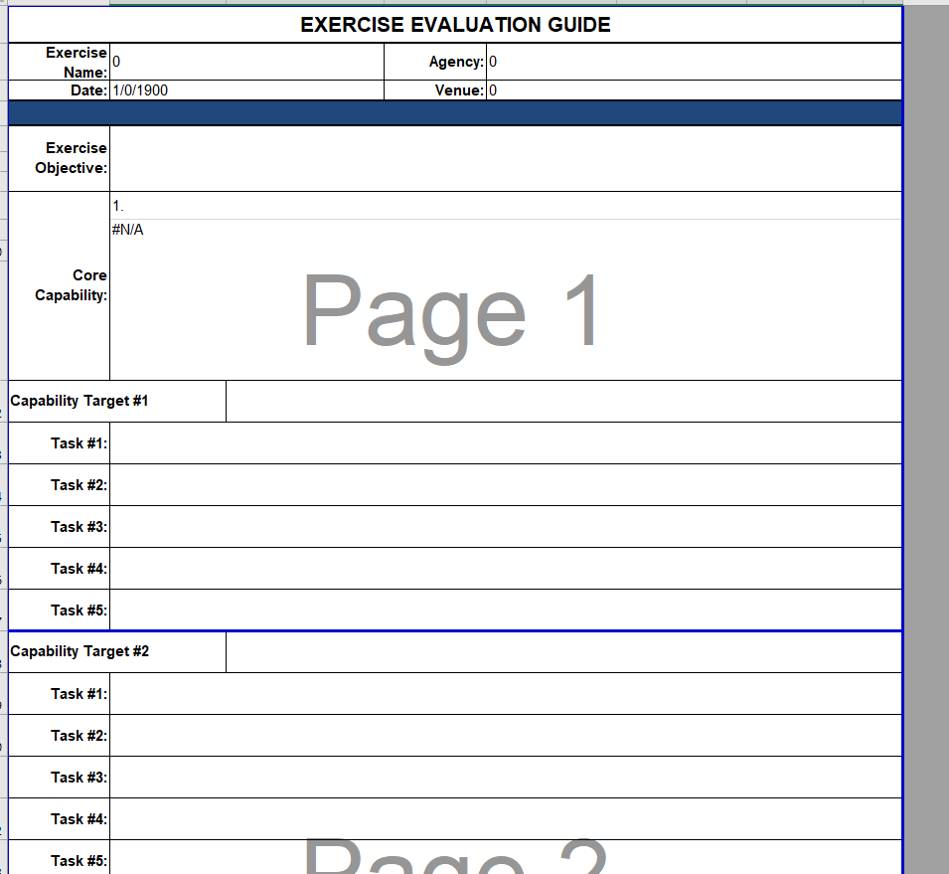

The Exercise Name, Agency, Date, Venue, Exercise Objective, and Core Capability will automatically appear once filled out in prior sections of the workbook. You will not be able to make any changes to those on the EEG sheet. In order to make a change, you must go back to the Notification Form Tab or the Exercise Overview Tab.

What to fill out on the EEG:
- Capability Target – This is the overall goal that you trying to achieve based on the objective written. To pick a capability target, search through your jurisdictional plans, policies, or procedures for items you wish to test that relate to the objective being tested. If you have multiple targets for the same objective, list them on individual Capability Target numbered lines. You may only have one specific target per capability target numbered line.

- Critical Tasks (Task above) – These are the individual steps taken to achieve the capability target selected. Critical Tasks must come from your plan, policy, or procedure that is being used for the EEG. They cannot be based upon what we think should happen or what happens. They must be documented in a jurisdictional plan, policy, or procedure in order to be evaluated.
  - You cannot evaluate any item that isn’t written into your plan, policy, or procedures.
  - Any plan, policy, or procedure used for the EEG must be one that you have the ability to change if that is identified as a corrective action. Basing your exercise evaluation on another department/agency plan, policy, or procedure is not allowed.

- Reference – This is where the name of your jurisdictional plan, policy, or procedure used for the EEG is listed. You may have more than one listed if multiple were used on the EEG. Separate multiple listings by a comma (,).

- Once you complete the reference line you are finished with the EEG during the planning phase. The lower part of the EEG is used by the evaluators when evaluating the exercise. This is the space they are taking their notes and assigning ratings based upon the ratings key at the bottom.

Evaluator Use of the EEG
Evaluators use the second half of the EEG created during the planning phase to look for identified targets and critical tasks deemed important by the exercise planner/planning team. This is where they document their observations for areas they see as needing improvement, strengths, and ratings. An evaluator may take additional notes on separate pieces of paper if they need additional spaces for writing. (Just make sure they keep the separate papers organized to determine what each note relates to capability target/task wise).

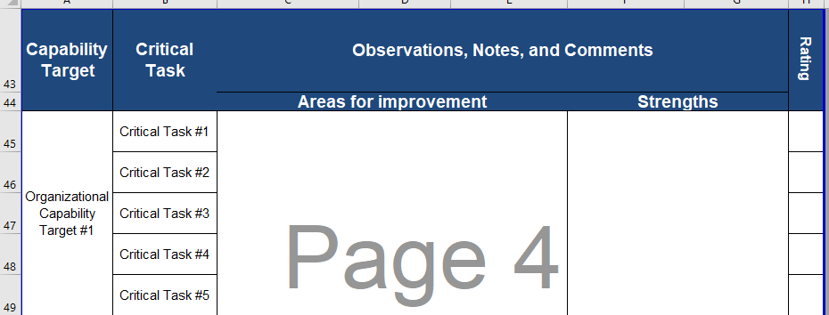

- Critical tasks will relate in order to the number of the task listed on the first half of the EEG (Before line 42).
- For each critical task the evaluator is observing to determine how each task was met according to the ratings page at the bottom of the EEG. (See Below)
- Evaluators should also look for things that went well during the exercise and make notes of those as well. This will help when you write the After-Action Report (AAR).
- Make sure the evaluators fill out the following at the bottom of the EEG incase more information is needed or a question arises from review of the EEG:

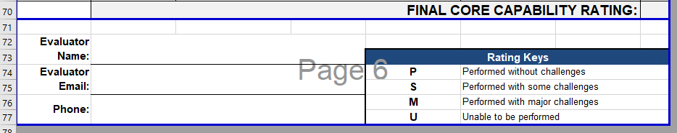

Understanding How to Assign the Final Core Capability Rating:
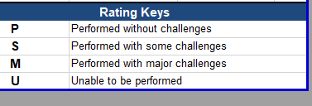

Using the ratings key above, assign each individual critical task a point total based upon the rating assigned. (See ratings key below for point values). Once that is completed, add all of the critical task scores together. Divide that number by the total number of critical tasks that were evaluated. Round any decimal number down to the nearest whole number. That whole number will correspond with one of the ratings below. Place the P, S, M, or U rating into the Final Core Capability Rating box on line 70 of the EEG.

Ratings Key:
  - P – Performed without challenges = 4
  - S – Performed with some challenges = 3
  - M – Performed with major challenges = 2
  - U – Unable to be performed =1

