MSEL 101

The Master Scenario Event List (MSEL) is the chronological listing of events that drives exercise play. Think of the MSEL as the script to a movie - every shot appears in the movie because of the script. Every action prompted in an exercise occurs because of the script (MSEL). The MSEL drives the exercise play towards meeting the exercise objectives. Every objective being tested and every item being evaluated on the Exercise Evaluation Guide (EEG) must appear in the MSEL as a prompt. You never leave items being tested or evaluated to chance. Failure to prompt the actions needed may result in not being able to fully test/validate your objective fairly.

What to Fill Out:
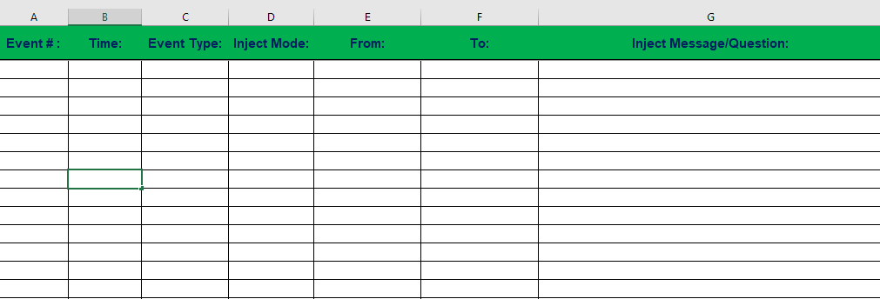

Column A – Event Number:
This is where you place numbers for every event listed in the MSEL. They are in chronological order starting at 1 and going sequentially thereafter.

Column B – Time:
This is where you list the time that each inject/question is delivered into the exercise play. The time is needed to help exercise controllers know when each item should be injected into exercise play. This allows for easy tracking of which inject/question you should be on at a specific time.

Column C – Event Type:
From the drop down box select player inject, media inject, or question for each entry. The type selected will be based on the following:
- Player inject – This inject is delivered to a specific player or group of players to prompt an action to be taken.
- Media inject – This inject is delivered to the player responsible for dealing with media related issues during the exercise. Keep a separate media MSEL for all media injects. This helps cut down on confusion when a Simulation Cell is delivering injects based upon the time column.
- Question – This is used for discussion based exercises like workshops or tabletops. Instead of listing injects to prompt an action, a question is listed that the facilitator will ask the group. The questions are asked in the time sequence established by Column B.

Column D – Inject Mode:
From the drop down box, select how that specific inject will be delivered to the exercise participants. You may use multiple methods during the exercise. (Note: If delivering a question in a discussion-based exercise, the inject mode will be in person).

Column E – From:
This is where you say who the person is delivering injects. (For Example: It may be County Coordinator Hearn, Sherriff Bob Jones, Fire Chief Smith, etc…………)

Column F – To:
This is where you say who is receiving injects or questions. This will be based upon each individual inject and who needs that information being delivered. (For Example: Is Fire Chief Smith relaying information to the EOC or to other fire departments?) {Note: When delivering a question in a discussion based exercise, who is always going to be the group. You wouldn’t have an exercise with several attendees and direct the questions at one individual}

Column G – Inject Message/Question:
This is where you will input the single inject message or question being delivered into exercise play based upon the time established in Column B.

