[Sponsor Organization]
  - Program Reporting
  - [Date]

Points of Contact

[Training POC:]
[Name]
[Title]
[Agency]
[Street Address]
[City, State ZIP]
[xxx-xxx-xxxx (office)]
[xxx-xxx-xxxx (cell)]
[e-mail]
[Exercise POC:]
[Name]
[Title]
[Agency]
[Street Address]
[City, State ZIP]
[xxx-xxx-xxxx (office)]
[xxx-xxx-xxxx (cell)]
[e-mail]
[Budget POC:]
[Name]
[Title]
[Agency]
[Street Address]
[City, State ZIP]
[xxx-xxx-xxxx (office)]
[xxx-xxx-xxxx (cell)]
[e-mail]

[Planning POC:]
[Name]
[Title]
[Agency]
[Street Address]
[City, State ZIP]
[xxx-xxx-xxxx (office)]
[xxx-xxx-xxxx (cell)]
[e-mail]
[Recovery & Mitigation POC:]
[Name]
[Title]
[Agency]
[Street Address]
[City, State ZIP]
[xxx-xxx-xxxx (office)]
[xxx-xxx-xxxx (cell)]
[e-mail]
[Hazard Analysis/Risk Assessments POC:]
[Name]
[Title]
[Agency]
[Street Address]
[City, State ZIP]
[xxx-xxx-xxxx (office)]
[xxx-xxx-xxxx (cell)]
[e-mail]

Purpose
[Modify and augment language in this section as appropriate.]
The purpose of Program Reporting is to provide an analysis of issues, trends and key outcomes of preparedness priorities such as those covered in a multi-year schedule of preparedness activities. The program report is designed to:
- Inform senior leaders on the progress of preparedness priorities;
- Provide data to support preparedness assessments and reporting requirements; and
- Enable exercise planners to modify objectives and the preparedness activity schedule to reflect knowledge gathered from the exercises process, so organizations can address known shortfalls prior to exercising capabilities.
[Provide a high-level summary as necessary. Consider specifying or describing:
- [Summary information about the preparedness activities conducted to date];
- [Major findings from exercises and real-world events]; and
- [Follow-on actions being taken to address major findings].
This Program Report covers the period of [date] to [date] and is designed to provide a summary of preparedness activities during this specified time and planned future activities.
[Example: This Program Report covers the period of Quarter 1 from January to March 2023. To date, based on the Integrated Preparedness Plan, the State has completed edits to the Emergency Operations Plan and it is now in coordination for approval. Procurement has begun the process of purchasing 3 new fire apparatus, training additional damage assessment teams and has completed the first of a series of 5 recovery tabletop exercises.]

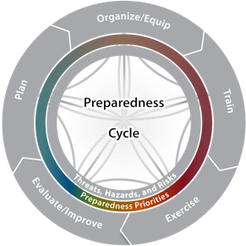

Preparedness Priorities
Below are the preparedness priorities identified during the Integrated Preparedness Planning Workshop and addressed in this Program Report:
Preparedness Priorities
- [insert]
- [insert]
- [insert]
- [insert]
- [insert]
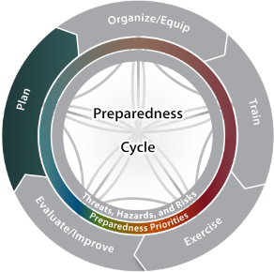

Planning Overview
Below are the planning actions and statuses for [timeframe]
Plan | Status | Priority Addressed
[Plan Name] | [Current Status] | [Priority]
[Plan Name] | [Current Status] | [Priority]
[Plan Name] | [Current Status] | [Priority]

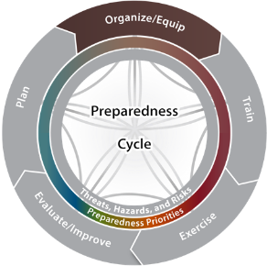
Organizational Overview
Below are the organizational changes and statuses for [timeframe]:
Organization/Department/Team | Status | Priority Addressed
[Org/Dept/Team] | [Current Status] | [Priority]
[Org/Dept/Team] | [Current Status] | [Priority]
[Org/Dept/Team] | [Current Status] | [Priority]

Equipment Overview
Below are the equipment changes and statuses for [timeframe]:
Equipment | Status | Priority Addressed
[Equipment] | [Status] | [Priority]
[Equipment] | [Status] | [Priority]
[Equipment] | [Status] | [Priority]
[Equipment] | [Status] | [Priority]
[Equipment] | [Status] | [Priority]

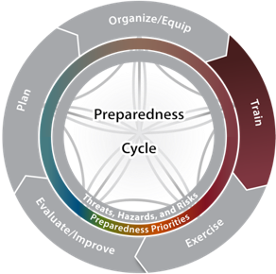

Training Overview
Below is the training that has been completed for [timeframe]:
Name | Date | # Trained | Priority Addressed
[Training] | [Training date] | [# trained] | [Priority]
[Training] | [Training date] | [# trained] | [Priority]
[Training] | [Training date] | [# trained] | [Priority]
[Training] | [Training date] | [# trained] | [Priority]
[Training] | [Training date] | [# trained] | [Priority]
[Training] | [Training date] | [# trained] | [Priority]
[Training] | [Training date] | [# trained] | [Priority]
[Training] | [Training date] | [# trained] | [Priority]
[Training] | [Training date] | [# trained] | [Priority]
[Training] | [Training date] | [# trained] | [Priority]
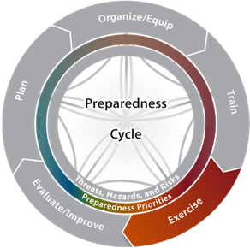

Exercise Overview
Below are the exercises that have been completed for [timeframe]:
Name | Date | Scenario/Hazard | Type
[Exercise name] | [Exercise date] | [Exercise scenario] | [Exercise type]
[Exercise name] | [Exercise date] | [Exercise scenario] | [Exercise type]
[Exercise name] | [Exercise date] | [Exercise scenario] | [Exercise type]
[Exercise name] | [Exercise date] | [Exercise scenario] | [Exercise type]
[Exercise name] | [Exercise date] | [Exercise scenario] | [Exercise type]
[Exercise name] | [Exercise date] | [Exercise scenario] | [Exercise type]

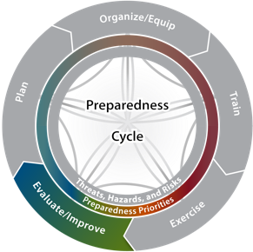

Corrective Actions

Key Findings:
- [Outline key findings from exercises and real-world events to date.]
[Consider highlighting information that would be important to key leadership.]
[Example: The State has demonstrated significant Public Information and Warning capability thus far during the exercise series. In one exercise, the timely warning information provided to operators at increased risk of a Cyber Incident allowed them to react quickly. In another exercise, the whole community was informed of pertinent recovery information through a range of communication vehicles including social media.]
Below are currently tracked corrective actions:
Corrective Action | POC | Repeat Finding | Estimated Completion Date
[Corrective Action] | [POC] | [Y/N] | [Date]
[Corrective Action] | [POC] | [Y/N] | [Date]
[Corrective Action] | [POC] | [Y/N] | [Date]
[Corrective Action] | [POC] | [Y/N] | [Date]
[Corrective Action] | [POC] | [Y/N] | [Date]
[Corrective Action] | [POC] | [Y/N] | [Date]

Preparedness Priority Review

Summary of Progress
[Priority]: [Include a brief summary of the goals and intent of this preparedness priority]

Capability Snapshot
[Include each capability related to this preparedness priority]
[Capability]

Key Actions:
- [Outline key actions taken toward improving this capability conducted to date.]
[Example: 3 new utility trucks purchased, 10 new employees hired and trained, 1 tabletop exercise to validate priority setting with ESF 3]

Future Actions:
- [Based on the information, include the newly assessed capability gap and actions still needed, including whether or not these activities are planned, or need to be addressed during a future Integrated Preparedness Planning Workshop.]
[Consider highlighting information that would be important to key leadership.]

Summary of Progress
[Priority]: [Include a brief summary of the goals and intent of this preparedness priority]

Capability Snapshot
[Include each capability related to this preparedness priority]
[Capability]

Key Actions:
- [Outline key actions taken toward improving this capability conducted to date.]
[Example: 3 new utility trucks purchased, 10 new employees hired and trained, 1 tabletop exercise to validate priority setting with ESF 3]

Future Actions:
- [Based on the information, include the newly assessed capability gap and actions still needed, including whether or not these activities are planned, or need to be addressed during a future Integrated Preparedness Planning Workshop.]
[Consider highlighting information that would be important to key leadership.]

Summary of Progress
[Priority]: [Include a brief summary of the goals and intent of this preparedness priority]

Capability Snapshot
[Include each capability related to this preparedness priority]
[Capability]

Key Actions:
- [Outline key actions taken toward improving this capability conducted to date.]
[Example: 3 new utility trucks purchased, 10 new employees hired and trained, 1 tabletop exercise to validate priority setting with ESF 3]

Future Actions:
- [Based on the information, include the newly assessed capability gap and actions still needed, including whether or not these activities are planned, or need to be addressed during a future Integrated Preparedness Planning Workshop.]
[Consider highlighting information that would be important to key leadership.]

Summary of Progress
[Priority]: [Include a brief summary of the goals and intent of this preparedness priority]

Capability Snapshot
[Include each capability related to this preparedness priority]
[Capability]

Key Actions:
- [Outline key actions taken toward improving this capability conducted to date.]
[Example: 3 new utility trucks purchased, 10 new employees hired and trained, 1 tabletop exercise to validate priority setting with ESF 3]

Future Actions:
- [Based on the information, include the newly assessed capability gap and actions still needed, including whether or not these activities are planned, or need to be addressed during a future Integrated Preparedness Planning Workshop.]
[Consider highlighting information that would be important to key leadership.]

Summary of Progress
[Priority]: [Include a brief summary of the goals and intent of this preparedness priority]

Capability Snapshot
[Include each capability related to this preparedness priority]
[Capability]

Key Actions:
- [Outline key actions taken toward improving this capability conducted to date.]
[Example: 3 new utility trucks purchased, 10 new employees hired and trained, 1 tabletop exercise to validate priority setting with ESF 3]

Future Actions:
- [Based on the information, include the newly assessed capability gap and actions still needed, including whether or not these activities are planned, or need to be addressed during a future Integrated Preparedness Planning Workshop.]
[Consider highlighting information that would be important to key leadership.]

